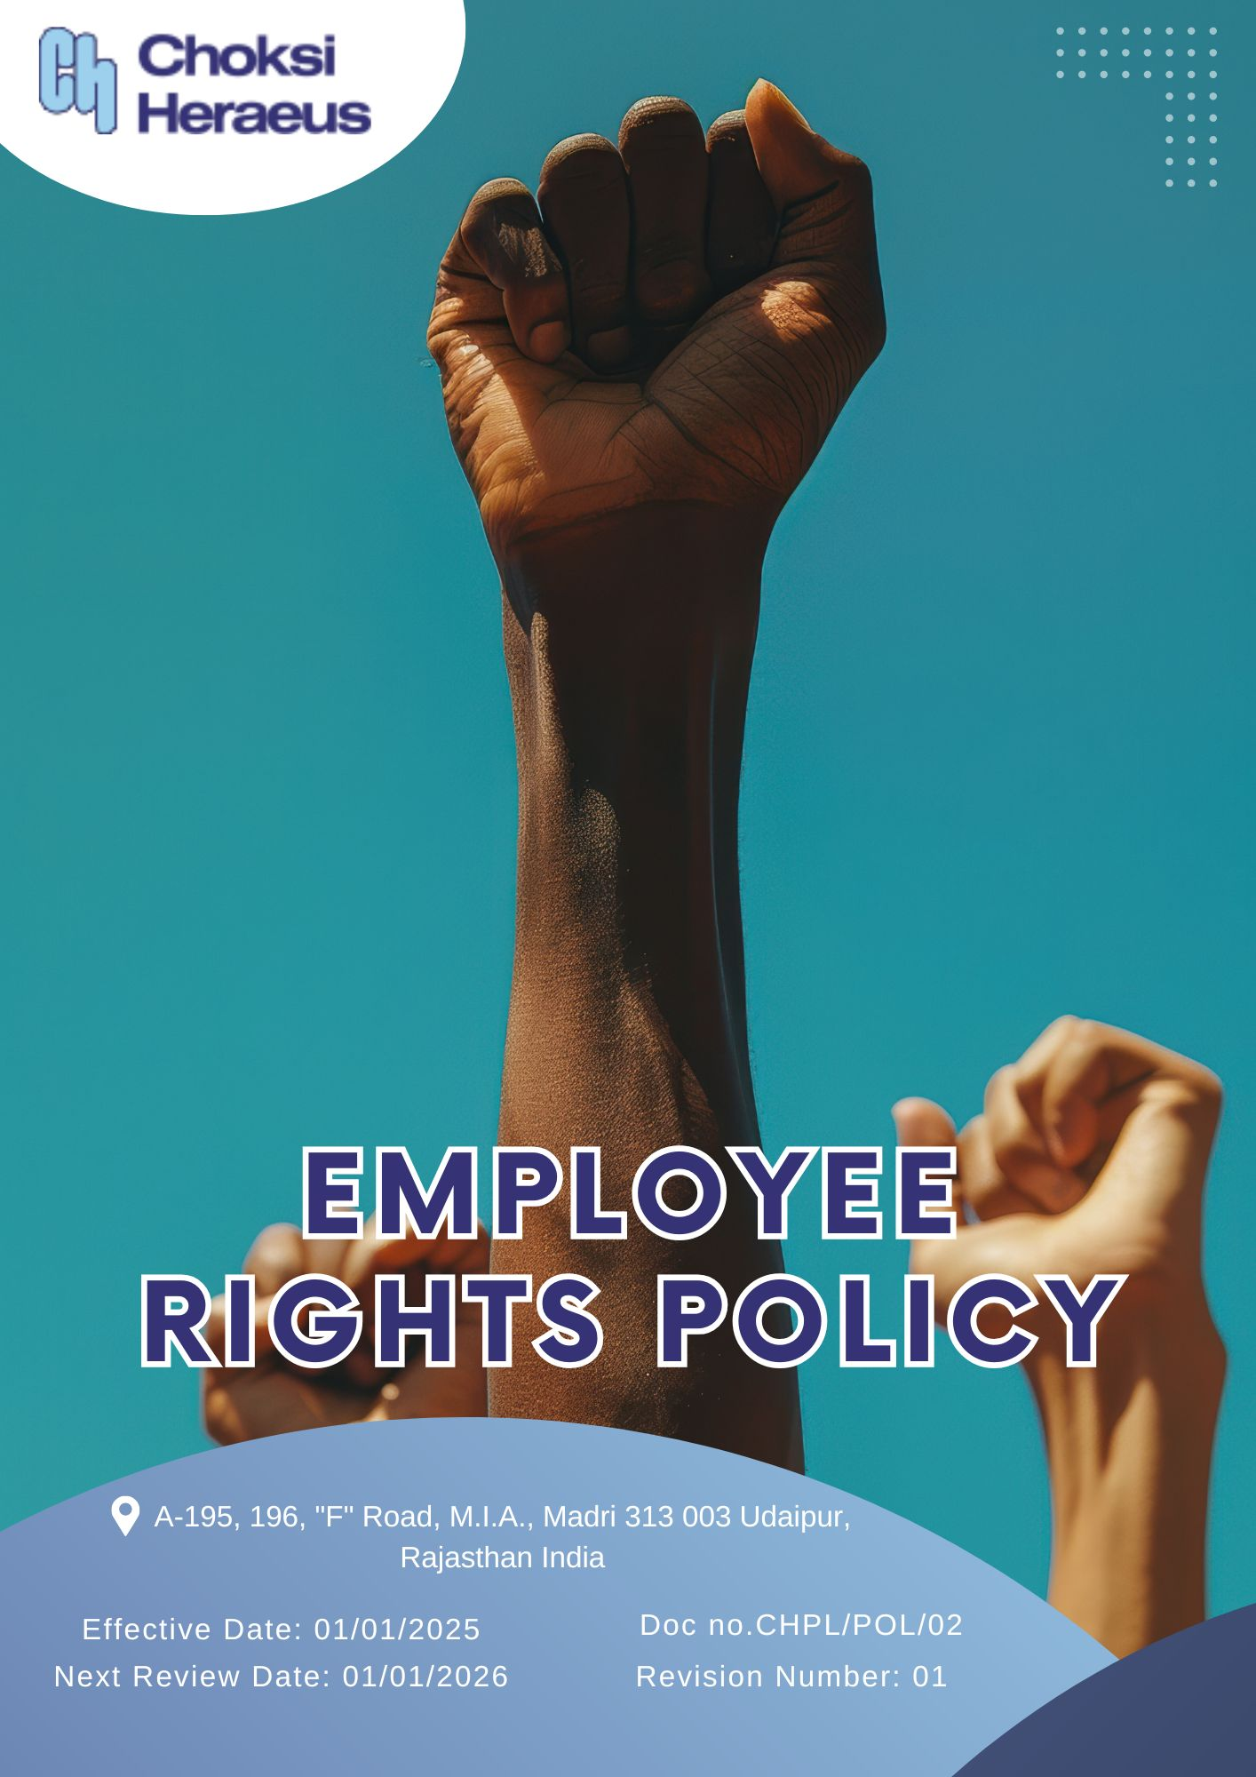

Table of Contents
Introduction 3
Scope 3
Policy Declaration 3
Key Focus Areas 4
Key Objectives and Targets 4
Targets in alignment with SDGs 6
Responsibility 7
Monitoring, Reporting & Transparency 7
Review Mechanism 7
Empolyee Acknowledgement 8

Introduction
Choksi (CHPL) is committed to upholding and safeguarding the fundamental rights of all employees, ensuring a fair, respectful, and inclusive work environment. This policy establishes the framework for promoting ethical labor practices, fostering diversity, and providing a safe and dignified workplace.
CHPL recognizes the importance of equitable treatment, non-discrimination, and fair wages while strictly prohibiting any form of forced or child labor. Employees are empowered with freedom of association, the right to collective bargaining, and access to grievance mechanisms without fear of retaliation.
Aligned with international labor standards and legal requirements, CHPL continuously strives to enhance workplace conditions, employee well-being, and professional growth opportunities. Through this commitment, the company reinforces its dedication to ethical employment practices, ensuring that every individual is treated with respect, fairness, and integrity.

Scope
This policy applies to all employees, including full-time, part-time, contractual, and temporary workers, as well as contractors and business partners of Choksi (CHPL). It covers fair wages, non-discrimination, workplace safety, freedom of association, and the prevention of forced or child labor. CHPL ensures compliance with labor laws and human rights standards, promoting a workplace based on dignity, equality, and ethical practices.
Sr. No. | Site | Address
1 | CHOKSI HERAEUS PVT. LTD | A-195, 196, "F" Road, M.I.A., Madri 313 003 Udaipur, Rajasthan India

Policy Declaration
Choksi (CHPL) recognizes that employees are the foundation of its success and is committed to fostering a workplace that upholds dignity, equality, and fairness. This policy ensures that all employees are provided with opportunities for growth, a safe and inclusive work environment, and protection from any form of discrimination or exploitation. CHPL is dedicated to maintaining transparent communication, ensuring employee participation in decision-making processes, and regularly reviewing labor practices to align with evolving legal and ethical standards.

Key Focus Areas
- Safe & Healthy Work Environment – Strengthen workplace safety measures, regularly assess occupational health risks, and provide accessible health and wellness resources.
- Fair & Supportive Workplace Practices – Uphold ethical working conditions that promote employee well-being, work-life balance, and job satisfaction.
- Open Communication & Employee Participation – Foster a culture of transparency and collaboration by ensuring structured engagement, grievance mechanisms, and regular dialogue between employees and management.
- Growth & Development Opportunities – Invest in career progression by offering training programs, skill enhancement initiatives, and structured internal mobility plans.
- Ethical Labor Practices & Human Rights Protection – Maintain strict policies against child labor, forced labor, and human trafficking while ensuring compliance across all business operations and supply chains.
- Inclusive & Equitable Work Culture – Promote diversity, equity, and inclusion by fostering an environment where all employees have equal opportunities and feel valued.
- Responsible Business Partnerships – Engage with external stakeholders, including suppliers and contractors, to ensure alignment with human rights and ethical labor standards.
- Competitive & Transparent Compensation – Provide fair wages, industry-aligned benefits, and structured pay scales that reflect employee contributions.
- Workplace Integrity & Respect – Implement strong policies against workplace harassment and discrimination, provide regular awareness training, and establish clear reporting mechanisms.

Key Objectives and Targets
All targets established under the Employee Rights Policy use FY 2022–23 as the baseline year. Progress will be reviewed annually, with goals aimed for achievement by FY 2028-29, covering key areas such as employee well-being, ethical labor practices, inclusivity, fair compensation, and responsible partnerships.
- Safe & Healthy Work Environment
- Regularly enhance health and safety protocols to proactively address workplace risks and promote employee well-being and hence maintain zero absenteeism due to work-related injuries.
- Ensure 100% accessibility to health and safety information and emergency protocols for all employees.
- To increase safety inspections by 5% till FY 2028-29 to proactively identify risks.

- Fair & Supportive Workplace Conditions
- Promote a workplace culture that prioritizes ethical practices, psychological safety, and employee satisfaction.
- Conduct employee satisfaction surveys annually on working conditions, aiming for 95% positive responses by FY 2028-29.
- Ensure implementation of a formal channel for 100% employees to discuss working conditions with management by FY 2028-29.

- Open Communication & Employee Participation
- Foster open dialogue through structured communication channels and inclusive participation in workplace decision-making.
- Ensure 100% of employees have access to formal platforms to express concerns and feedback.
- To conduct annual labor-management meetings with documented minutes and action points.

- Growth & Development Opportunities
- To conduct annual performance reviews to support career advancement and encourage internal mobility by promoting from within when possible.
- Allocate 10% of the annual budget to employee development programs by FY 2028-29.
- Increase internal promotions by 10% by FY 2028-29 by implementing structured career pathways and targeted upskilling programs.

- Ethical Labor Practices & Human Rights Protection
- Enforce and maintain zero-tolerance policies on child and forced labor throughout our operations.
- Conduct background checks for 100% of new suppliers before onboarding regularly.
- Ensure 100% supplier compliance with child & forced labor policies through annual supplier audits

- Inclusive & Equitable Work Culture
- Promote an inclusive environment that respects individual differences and ensures equitable access to opportunities.
- Deliver annual DEI training to 100% of employees.
- Achieve a 60% positive response rate in DEI-related questions in employee surveys by FY 2028-29.

- Responsible Business Partnerships
- Extend employee rights and labor standards through the supply chain by aligning with responsible suppliers and vendors.
- Ensure that 100% of supplier contracts include and comply with human rights clauses by the FY 2028-29.
- Conduct supplier training on ethical labor standards by annually.

- Competitive & Transparent Compensation
- Ensure employees receive industry-competitive wages and benefits with transparent pay structures.
- Benchmark compensation packages every year to align with industry standards.
- Conduct compensation transparency workshops annually.

- Workplace Integrity & Respect
- Maintain a harassment-free environment through education, zero-tolerance policies, and clear redressal systems.
- Conduct annual workplace conduct training for 100% of employees.

Targets in alignment with SDGs
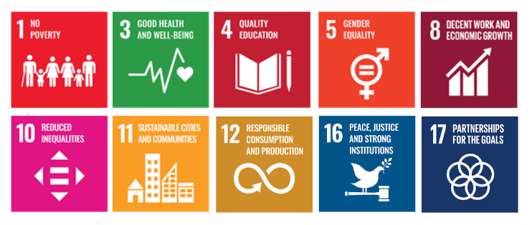

Responsibility
The following teams and individuals are jointly responsible for upholding and implementing the Employee Rights Policy at Choksi Heraeus Pvt. Ltd.:
- Management – Promote a respectful workplace and provide necessary support.
- HR Department – Communicate the policy, manage employee records, and address grievances.
- Supervisors– Ensure fair practices and support employee well-being.
- Employees – Respect others' rights, follow the policy, and report violations.
- ESG Team – Monitor compliance, conduct audits, and update the policy as needed.

Monitoring, Reporting & Transparency
Choksi Heraeus is committed to maintaining transparency in the implementation of its Employee Rights Policy by establishing a structured monitoring and reporting framework. Key aspects such as fair labor practices, working conditions, equal opportunity, and grievance resolution will be regularly tracked and documented. Periodic internal reviews and audits will be conducted to assess compliance with labor laws, company policies, and social responsibility standards.
Key indicators related to employee well-being and rights will be evaluated, and findings will be reported to senior management and relevant internal stakeholders. Additionally, an annual internal review of employee rights performance will be carried out, highlighting progress, identifying areas for improvement, and guiding future actions to ensure accountability, inclusivity, and continuous improvement in our workplace practices.

Review Mechanism
The HR Manager at Choksi Heraeus will conduct annual reviews to evaluate the effectiveness of the employee rights policy, ensure compliance with applicable standards, and revise targets where necessary. The review process involves analyzing quarterly reports, collecting employee feedback, and benchmarking practices against industry standards. Key findings are reported to the CEO, and necessary adjustments are made to uphold continuous improvement in labor and human rights practices across all operations.
Effective Date: 01.01.2025
Next Review Date: 01.01.2026
Approved By:

Empolyee Acknowledgement
I hereby acknowledge that I have read and understood the Employee Rights Policy of Choksi Heraeus Pvt. Ltd. I am aware of the company’s commitment to upholding fair labor practices, ensuring a safe, respectful, and inclusive work environment, and protecting the rights and well-being of all employees.
I understand that every employee has the right to fair treatment, non-discrimination, freedom of association, just compensation, and safe working conditions. I recognize that these rights are fundamental and that maintaining a respectful, ethical, and compliant workplace is a shared responsibility.
By signing this document, I commit to respecting the rights of my colleagues, reporting any violations or concerns through appropriate channels, and participating in training and awareness programs related to employee rights and workplace ethics. I affirm my support for Choksi Heraeus’ dedication to a transparent, equitable, and rights-based workplace culture.

Employee Name  Employee ID  Date  Signature | :_______________________________  :_______________________________ :________________________________  : _______________________________

